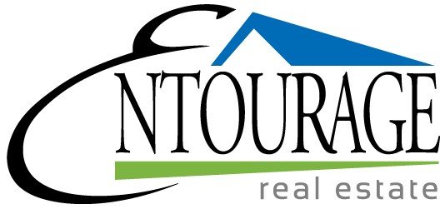

Date
Name
Address
Address
Dear,

I see you've decided to market your home on your own, and why not? If you have the skills and time to sell your property without professional assistance, I can certainly understand why you would choose this route.

My name is Marla, and I'm a BROKER who specializes in listing and selling homes in your area. As such, I not only have a lot of great resources to help you market your home, but also a great deal of respect for anyone trying to navigate the current real estate situation.

If you're not used to it, selling real estate can be very confusing and complex at the best of times. And now is not the best of times for sellers. Because of this, I've compiled a handy FSBO Resource Kit to give you some of the benefit of my knowledge and experience.

This free resource kit is loaded with tools and tips for selling your home, including pricing information, marketing techniques, staging guidelines, document checklists, security advice, suggestions for boosting curb appeal, and strategies for negotiation.

I also have excellent connections with loan officers and title companies. So if you find an interested buyer, I'll be happy to connect you with the right people to help with financing and clearing title.

If you are interested in adding ideas from an experienced, successful BROKER to your repertoire of selling strategies, give me a call at 832-868-6091, and I'll mail you a copy of my complimentary FSBO Resource Kit. You may also wish to take a look at my Web site at EntourageRealtors.com for information about the innovative real estate services I provide. And if you require any assistance, I'm only a phone call away.

Sincerely,

Marla Lewis
Broker

